Welcome to our Photovoice and
Family Communication Study

Thank you so much for wanting to learn more about our study. We think it is important to learn from siblings and parents of children who have serious illnesses about:
- Ways to best help siblings and families in this situation
- How communication or talking about important topics can be hard
- The ways you start conversations
- Whether the way we ran the study was helpful

Why are we using photographs in our study and not just surveys?
- Photographs help tell a story when we don’t know the right words
- Taking a photo can be fun and freeing, surveys can limit what we learn
- Pictures and photos are universal. It does not matter what language you speak, we can all see the photo
- We thought siblings would like to tell their story using photos

What are the steps in this project?
This study requires participation by both the sibling and the parent.
- Email Kim Mooney-Doyle at kmooney-doyle@umaryland.edu and let her know your family is interested in participating.
- The research team will set up a time to talk on the phone about the study so they can answer any questions you might have.
- If a parent and sibling decide they want to take part in the study, you will be asked to sign a permission form.
- A camera and a prepaid envelope to return the camera will be sent to you.
- After you get the camera, another call will be scheduled with the researcher to review the steps one more time. This is when you get the list of questions to think about and answer in photos (see examples below)
- Over 2 weeks, you take 10-20 pictures to answer the questions. You can also use photos you may have on a personal camera. We want you to use the photos that answer the questions best.
- When you are done with the photos, you mail camera back using the pre-paid envelope.
- When the team has received the camera, they will set up a time to talk/video conference about what the photos mean to you and how they show your answers to the questions.

How do I tell a story with a photo?
Here are a few examples of questions and how the photo answered it.
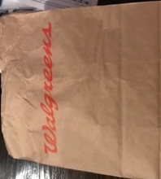
What helps when I talk with my sibling about hard stuff?
This is a picture of a bag from when my sister and I walked to the store alone. It helps talking about things when we’re alone and she feels good.

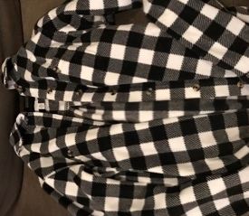
When is it hard to talk about your sibling’s illness with them?
This is a picture of a shirt we both have. She got mad when I wore it at the same time. It’s hard to talk when she gets mad and I don’t know what will make her upset. When she’s upset, everyone’s upset.

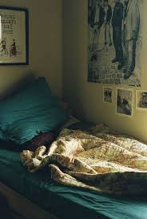
When is talking to your parents about your brother or sister easiest?
This is a picture of my bed. Sometimes my mom comes in to snuggle with me before bed. Usually this when I can bring up tough stuff. I wish she did it more.
How will we use this information we gather in this study?
We will use the photos and their descriptions from the interview in research papers and presentations. These papers and presentations are important to teach nurses, physicians, psychologists, socials workers, child life specialists, and others how take better care of siblings and families when another child in the family is seriously ill.

What do I do if I have a problem or question while participating?
If you have problems with your camera or questions, call or text Kim at 215-514-1707. She is in charge of this part of the study and will help you.

